SQL-Based Receivables Analytics and Risk Monitoring System

Problem Statement
Many organizations operate on credit-based sales, where customers are allowed to pay after an invoice is issued. While this helps drive business, it also creates challenges in tracking unpaid invoices, delayed payments, and customer credit risk. Invoice, payment, and customer data are often stored across multiple tables, making it difficult to get a single, accurate view of outstanding receivables.
In addition, real-world financial data frequently contains inconsistencies such as duplicate payments, incorrect allocations, overdue invoices marked as paid, or payments applied to invalid invoices. Without proper validation, these issues can lead to misleading financial metrics and poor decision-making. Teams also struggle to measure how effective their collection efforts are and which customers require priority attention.
The purpose of this project is to build a structured, SQL-based receivables analytics system that converts raw transactional data into meaningful and reliable insights. By creating a single source of truth for invoice balances, analyzing overdue behavior, evaluating collection effectiveness, identifying high-risk customers, and performing data quality checks, the project aims to support better cash flow management, improved collections strategy, and trustworthy financial reporting.

Project Data Preparation & Ingestion Summary
In this project, a complete Accounts Receivable (AR) and Collections analytics database was designed and implemented using MySQL, following industry-standard data engineering practices.
Initially, multiple raw CSV files representing business entities—customers, invoices, payments, invoice allocations, dunning actions, and credit notes—were provided as the source data. These datasets contained real-world data issues such as mixed date formats, inconsistent schemas, and strict NOT NULL requirements, which prevented direct loading into fully constrained tables.
To address this, a two-layer ingestion approach was adopted.

1. Staging Layer Creation
Dedicated staging tables (stg_*) were created for all six datasets.
In the staging layer:
- Date fields were stored as VARCHAR instead of DATE
- No primary keys or foreign key constraints were enforced
- The objective was to ingest raw data without rejection
This ensured that all records from the CSV files were successfully loaded, even with inconsistent date formats (e.g., MM/DD/YYYY and DD-MM-YYYY).

2. Production Table Design
Final production tables were created with:
- Primary keys for entity uniqueness
- Foreign key constraints to enforce referential integrity
- NOT NULL constraints for critical financial fields
- Proper DATE data types for all temporal columns
- • Conditional date normalization using CASE and STR_TO_DATE
- • Standardization of date values into MySQL’s YYYY-MM-DD format
- • Preparation of clean, analytics-ready data

This schema accurately models real-world AR workflows, including partial payments and invoice-to-payment allocations.

4. Data Loading into Final Tables
Cleaned data was inserted into production tables using INSERT INTO … SELECT statements from staging tables.
This step ensured:
- No silent data loss
- Fully validated and consistent records
- Readiness for financial analytics such as AR Aging, DSO, collections effectiveness, and risk scoring

5. Cleanup and Finalization
Earlier incorrect or partially created tables were safely dropped in a controlled order to avoid foreign key conflicts.
Staging tables were retained to support:
- Re-runs of transformations
- Auditing and traceability
- Demonstration of ETL best practices during evaluation

ER DIAGRAM
Relationship | Type
Customers → Invoices | 1 : Many
Customers → Payments | 1 : Many
Invoices → Dunning Actions | 1 : Many
Invoices ↔ Payments | Many : Many (via invoice_payments)
Invoices → Credit Notes | 1 : Many

The ERD represents a normalized Accounts Receivable system. Customers generate invoices and make payments. Payments can be partially or fully allocated to invoices through an allocation table, enabling accurate balance computation. Overdue invoices trigger dunning actions, and credit notes are used to adjust invoice values. Referential integrity is enforced using primary and foreign keys

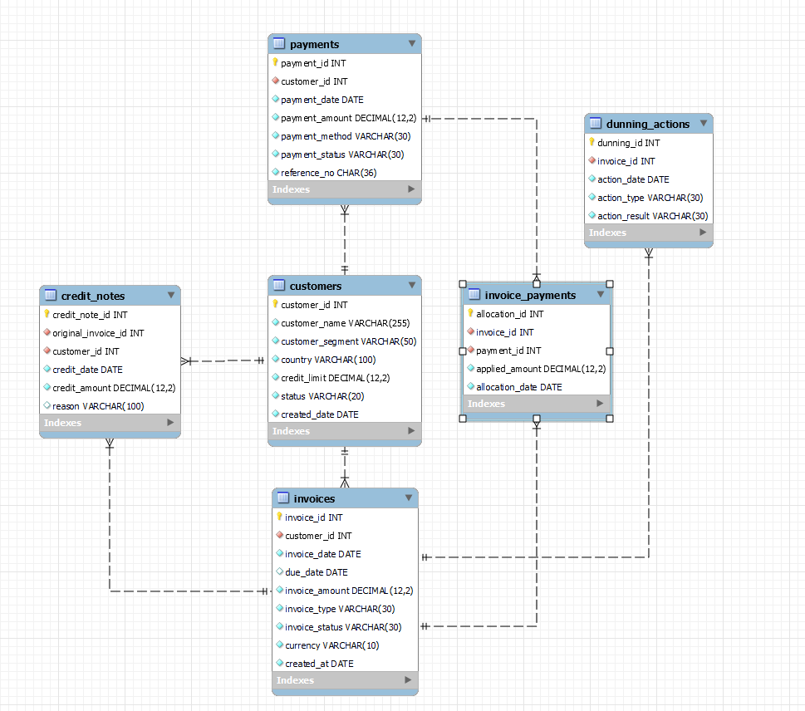

1.Core Metric Layer (Source of Truth)
The core metric layer represents the source of truth for the project, meaning it is the single trusted place from which all financial insights are derived. In this layer, data from multiple tables—such as invoices, invoice payments, and payments—is joined together to form a complete and accurate picture of each invoice. These joins are necessary because invoice details and payment details are stored separately in raw data. By combining only valid (successful) payments with their corresponding invoices, the layer ensures that calculated metrics like total amount paid, remaining balance, and overdue status are correct and consistent. As a result, all reports and analyses rely on the same verified data, eliminating inconsistencies and ensuring reliable financial reporting.
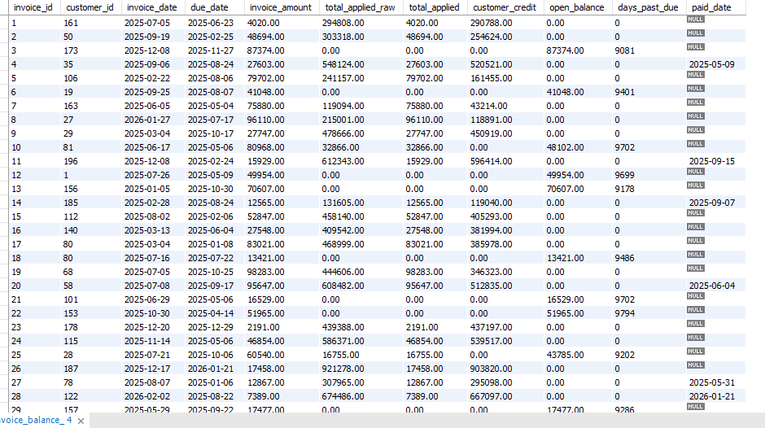

Handling Overpayments and Customer Credit
In real-world financial systems, payments applied to an invoice may sometimes exceed the invoice amount due. This situation does not indicate an error by the customer but usually occurs due to advance payments, bulk payments covering multiple invoices, or temporary allocation inconsistencies in raw transactional data. To correctly handle such scenarios, the core metric layer introduces a separate customer credit measure. The applied payment amount is capped at the invoice value to ensure that the open balance never becomes negative. Any excess amount beyond the invoice total is captured as customer credit, representing funds that can be adjusted against future invoices. This approach aligns the data model with standard accounting practices, improves data reliability, and ensures that all financial reporting is based on accurate and business-validated logic.

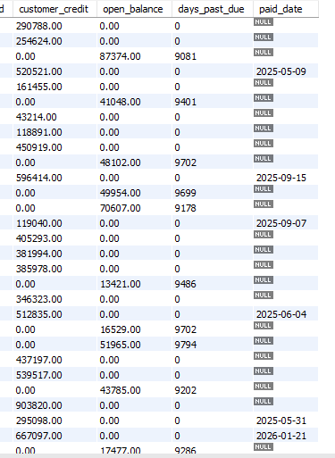

2.Customer AR Snapshot and Credit Exposure Analysis
To evaluate customer-level credit exposure and payment risk, a consolidated customer accounts receivable (AR) snapshot is created. This snapshot aggregates invoice-level information into a single view per customer, enabling consistent monitoring of outstanding balances, aging behavior, and credit utilization.

Open Accounts Receivable (Open AR)
Open AR represents the total unpaid amount that a customer currently owes.
It is calculated by summing the open balances of all invoices associated with a customer. Fully paid invoices contribute zero, while partially paid or unpaid invoices contribute their remaining balance.
This metric reflects the current financial exposure the company has toward each customer.

Aging Bucket Distribution
To assess payment behavior and risk, open balances are categorized into aging buckets based on how long invoices have been overdue. Typical buckets include:
- Current (not yet due)
- 1–30 days overdue
- 31–60 days overdue
- 61–90 days overdue
- 90+ days overdue
By splitting open AR into these buckets at the customer level, it becomes possible to distinguish between temporary delays and chronic late payments, which is critical for prioritizing collection efforts.

Credit Limit
Each customer is assigned a credit limit, which defines the maximum amount of unpaid balance they are allowed to have at any point in time. Credit limits are established based on factors such as customer size, historical payment behavior, and financial reliability.
The credit limit acts as a risk control mechanism, ensuring that the company’s exposure to any single customer remains within acceptable bounds.

Credit Utilization Ratio
The credit utilization ratio measures how much of a customer’s approved credit limit is currently being used. It is calculated as the ratio of total open AR to the assigned credit limit.
This ratio provides a clear indicator of credit risk:
- Lower ratios indicate available credit capacity and lower risk
- Higher ratios indicate increased exposure and potential payment risk
- Ratios above 100% signal that the customer has exceeded their approved credit limit
Credit utilization is a widely used metric in finance teams to determine whether to continue extending credit, place customers on credit hold, or prioritize collection actions.

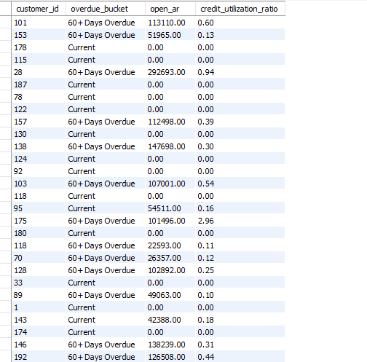

3. Sales Outstanding (DSO) Analysis
Days Sales Outstanding (DSO) is a key financial performance metric used to measure the average number of days a company takes to collect payment after a sale has been made. It reflects the efficiency of the organization’s credit and collections process. A lower DSO indicates faster cash collection and healthier cash flow, while a higher DSO suggests delays in customer payments and increased receivables risk.
In this project, DSO was calculated using monthly sales and month-end accounts receivable (AR). Monthly sales were derived by aggregating invoice amounts based on the invoice issue date, representing the value of sales generated in each month. Month-end AR was calculated by identifying all invoices that remained unpaid as of the end of each month, regardless of when the invoices were created. This approach ensures that receivables from prior periods are correctly included and that the AR value represents a true snapshot of outstanding balances at month-end.
The DSO metric was then computed using the standard formula:
DSO = (Month-End AR / Monthly Sales) × Number of Days in the Month.
Normalizing by the number of days in each month allows fair comparison of DSO values across different periods.
Finally, a month-wise DSO trend was generated to analyze changes in collection efficiency over time. This trend helps identify patterns such as improving or deteriorating payment behavior and supports data-driven decisions related to credit policy and collections strategy.
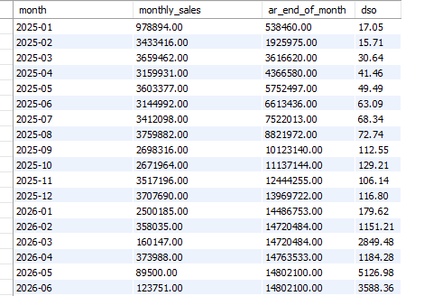

4. Collections Effectiveness Analysis
Collections effectiveness analysis evaluates how successful different follow-up actions are in recovering overdue payments. These follow-up actions, referred to as dunning actions, include communication methods such as emails, phone calls, and formal notices. The objective of this analysis is to understand which actions lead to faster and more frequent payments and how their effectiveness varies across customer segments.

Payment Success Measurement
For each dunning action recorded against an invoice, the analysis checks whether the invoice was fully paid after the action was taken. Payment success is evaluated within three standard time windows: 7 days, 14 days, and 30 days following the action date. If an invoice is paid within a given time window, the action is considered successful for that window. This approach helps measure both immediate and delayed customer responses to collection efforts.

Success Rate Calculation
To calculate success rates, each dunning action is assigned a binary indicator: a value of 1 if the invoice was paid within the specified time window and 0 otherwise. The success rate is then calculated as the average of these indicator values and expressed as a percentage. For example, a 7-day success rate of 6.52% indicates that approximately 6 out of every 100 collection actions resulted in payment within seven days.

Comparison by Action Type and Customer Segment
The effectiveness of dunning actions is analyzed by grouping results based on action type (Email, Call, Notice) and customer segment (SMB, Mid-market, Enterprise). This comparison highlights how different communication methods perform across customer categories and helps identify which strategies are more effective for specific segments.

Average Days to Pay After Action
In addition to success rates, the analysis calculates the average number of days taken by customers to pay after a dunning action. This metric measures the speed of payment response rather than just whether payment occurred. Lower values indicate quicker responses and higher effectiveness. In some cases, negative values may appear, indicating that payment was recorded before the corresponding dunning action, which reflects timing or logging inconsistencies in the operational data.

Technical Explanation: Collections Effectiveness Query
- A Common Table Expression (CTE) is first created to evaluate the outcome of each individual dunning action.
- Each dunning action is linked to its corresponding invoice and customer to identify the customer segment.
- The invoice balance source-of-truth view is used to obtain the final payment date of the invoice.
- The number of days taken to pay after a dunning action is calculated by comparing the payment date with the action date.
- Binary indicators (1 or 0) are generated to identify whether the invoice was paid within 7 days, 14 days, and 30 days after the action.
- These indicators allow payment success to be measured consistently across different time windows.
- In the final step, results are aggregated by action type and customer segment.
- Success rates are calculated by averaging the binary indicators and converting them into percentages.
- The average number of days to pay after a dunning action is calculated to measure payment response speed.
- Negative values in the average days metric indicate cases where payment was recorded before the action date, reflecting timing inconsistencies in the source data.
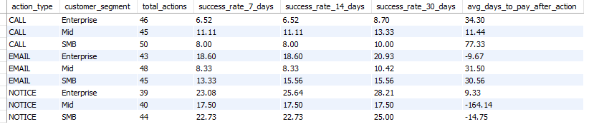

5. Customer Risk List
The Customer Risk List is designed to identify and rank customers based on their likelihood of delayed or failed payments. Instead of looking at individual invoices, this deliverable evaluates risk at the customer level by combining multiple indicators related to overdue exposure, payment behavior, and credit usage. The objective is to help finance and collections teams prioritize high-risk customers for follow-up actions.
Risk Features Used
- Total Overdue Amount
Represents the total unpaid balance for all overdue invoices of a customer. Higher overdue amounts indicate greater financial exposure.
- 90+ Days Overdue Amount
Captures the portion of overdue balance that is more than 90 days past due. This is considered high risk, as long-outstanding receivables have a lower probability of recovery.
- Number of Overdue Invoices
Counts how many invoices are overdue for a customer. Multiple overdue invoices suggest recurring payment delays rather than a one-time issue.
- Failed or Reversed Payments (Last 60 Days)
Identifies customers with recent failed or reversed payment attempts. This signals payment reliability issues and potential cash flow problems on the customer side.
- Credit Limit Exceeded
Flags customers whose total outstanding balance exceeds their assigned credit limit. Exceeding the credit limit indicates increased credit risk and the need for tighter controls.
- Overdue Trend (Optional)
A month-over-month increase in overdue balances can indicate worsening payment behavior and emerging risk.

Risk Scoring and Ranking
Each risk feature contributes a small, predefined score. Features representing more severe risk (such as 90+ overdue amounts or credit limit breaches) carry higher weight. The individual scores are summed to create a simple composite risk score for each customer. Customers are then ranked from highest to lowest risk, enabling focused and data-driven collection prioritization.
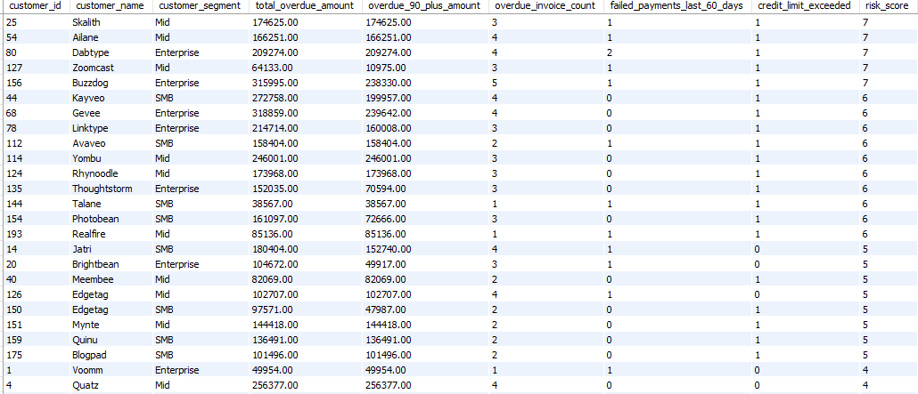

6. Data Quality and Anomaly Checks
Data quality and anomaly checks are essential to ensure that financial analysis and reporting are based on accurate, consistent, and reliable data. In transactional finance systems, data is often generated from multiple sources and processes, which can lead to duplication, incorrect allocations, or inconsistent statuses. Before building metrics such as DSO, risk scores, and collections effectiveness, it is necessary to validate the underlying data and identify potential anomalies.
The following checks were implemented to detect common real-world data issues observed in payment and invoicing systems.

1. Duplicate Payments
Duplicate payments occur when the same payment reference number appears more than once in the system. This can happen due to system retries, manual re-entries, or integration issues with payment gateways. Duplicate records can lead to overstated cash inflows and incorrect payment allocations if not detected and handled properly. This check helps ensure that each payment reference is treated as a unique financial transaction.
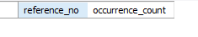

2. Over-Applied Payments
An over-applied payment is identified when the total amount allocated from a payment exceeds the actual payment amount received. This situation usually indicates allocation errors, incorrect manual adjustments, or missing reversals. Over-application can result in negative balances or inflated paid amounts on invoices, making financial metrics unreliable. Detecting this anomaly ensures that payment allocations remain within the limits of actual received cash.

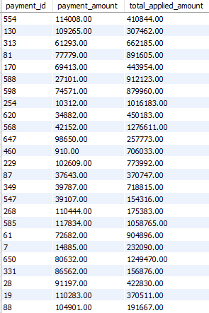

3. Allocations to Failed or Reversed Payments
Failed or reversed payments do not represent valid cash receipts. However, due to timing issues or incorrect processing, such payments may still be allocated to invoices. This check identifies invoice allocations linked to payments that have a failed or reversed status. Detecting such cases ensures that only successful payments are considered in receivable and collection calculations.

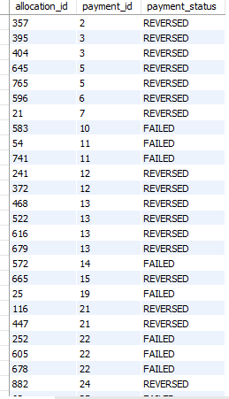

4. Invoice Marked as Paid but Open Balance Exists
An invoice is considered fully paid only when its outstanding balance reaches zero. In some cases, an invoice may be marked as “PAID” in the system while still having a non-zero open balance due to partial payments, incorrect status updates, or missing adjustments. This inconsistency can lead to incorrect reporting of receivables. This check identifies such mismatches to maintain consistency between invoice status and actual financial balances.
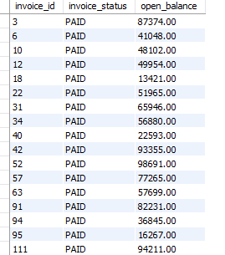

5. Payments Applied to Void Invoices
Void invoices are invoices that have been canceled and should not receive any payments. Payments applied to void invoices usually indicate system configuration issues, incorrect manual allocations, or delayed status updates. This check identifies such invalid allocations to ensure that payments are only applied to active and valid invoices.
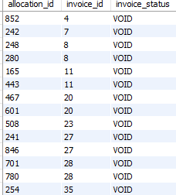

7. Performance Optimization Using Indexes
To improve query performance, database indexes were created on frequently accessed columns used in joins and filtering conditions. Indexes help the database locate relevant records faster, especially for large transactional tables such as invoices and payments. These indexes were implemented at the database level using a separate SQL script, following real-world best practices.
Indexes were added on customer and date-related columns in the invoices table to optimize receivables and aging queries. Additional indexes were created on invoice–payment linkage columns to improve allocation and reconciliation queries, and on customer and payment date columns in the payments table to speed up recent payment and collections analysis.
By creating these indexes separately from analytical queries and views, the system remains maintainable while ensuring faster execution of heavy reports and dashboards.
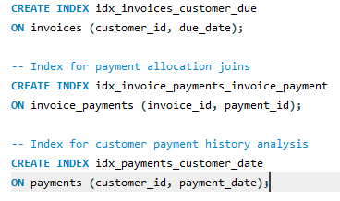

KPIs Used in This Project

1. Open Balance
Definition:
The remaining unpaid amount of an invoice after considering all successful payment allocations.
Purpose:
Indicates how much money is still expected to be collected from customers.

2. Total Overdue Amount
Definition:
The total outstanding balance for invoices that have passed their due date.
Purpose:
Measures the overall exposure to late payments.

3. Days Past Due (DPD)
Definition:
The number of days an invoice remains unpaid after its due date.
Purpose:
Helps identify how late payments are and supports aging analysis.

4. Accounts Receivable (AR)
Definition:
The total amount owed by customers at a given point in time.
Purpose:
Represents expected future cash inflows from credit sales.

5. Days Sales Outstanding (DSO)
Definition:
The average number of days it takes to collect payment after a sale is made.
Formula:
DSO = (Month-End AR / Monthly Sales) × Days in Month
Purpose:
Measures the efficiency of the collections process and cash flow performance.

6. Collection Success Rate (7 / 14 / 30 Days)
Definition:
The percentage of collection actions that resulted in payment within 7, 14, or 30 days after the action.
Purpose:
Evaluates how effective different collection methods are over time.

7. Average Days to Pay After Action
Definition:
The average number of days taken by customers to pay after a collection action is performed.
Purpose:
Measures the speed of customer response to collection efforts.

8. Overdue Invoice Count
Definition:
The number of invoices that are overdue for a customer.
Purpose:
Indicates recurring payment issues and customer payment behavior.

9. 90+ Days Overdue Amount
Definition:
The portion of overdue balance that has been outstanding for more than 90 days.
Purpose:
Highlights high-risk receivables with low recovery probability.

10. Credit Utilization
Definition:
The ratio of a customer’s outstanding receivables to their assigned credit limit.
Formula:
Credit Utilization = Open AR / Credit Limit
Purpose:
Assesses customer credit risk and exposure.

11. Credit Limit Exceeded
Definition:
A binary indicator showing whether a customer’s outstanding balance exceeds their credit limit.
Purpose:
Flags customers with elevated credit risk.

12. Failed / Reversed Payment Count
Definition:
The number of failed or reversed payment attempts within a recent time period.
Purpose:
Indicates payment reliability issues.

13. Customer Risk Score
Definition:
A composite score created by combining multiple risk indicators such as overdue amount, aging severity, payment failures, and credit limit breaches.
Purpose:
Ranks customers based on overall financial risk.

14. Data Quality Issue Count
Definition:
The number of detected data anomalies related to payments and invoices.
Purpose:
Ensures reliability and accuracy of financial reporting.

